Service Schedule – “SPIDR Tech Product”

This Service Schedule No. [number] is effective as of [date] and is made by [name of customer] ("Customer") and Versaterm Public Safety US, Inc. ("Versaterm"). This "Service Schedule" and its schedules (if applicable) are incorporated into that certain Master Software and Services Agreement dated [date], between Customer and Supplier ("MSA"). The terms and conditions that are specific to this Service Schedule are set forth herein. In the event of a conflict between the provisions of this Service Schedule and the Master Agreement, the provisions of Section 2 a) of the MSA shall control such conflict. Capitalized terms herein will have the meanings set forth in the MSA, " or the "Definitions" as further defined below.
- Service Schedule Information
  - Software/Subscription Service: [Insert Software/Module]
  - Authorized Users/Sworn Count: [Insert number of users or site license]
  - Subscription Term: [Insert start date to end date]
  - Fees:
[Fees table placeholder]
Versaterm shall send invoices to Customer at the following e-mail address: [Insert e-mail address]
The Fees indicated above may be subject to a price increase as per the MSA.
- Definitions
Any capitalized word or term used in this Service Schedule but not otherwise defined herein shall have the meaning given to it in the Master Software and Services Agreement.
  - [placeholder]
- License
  - Provision of the Service. Versaterm will provide Customer with access to Versaterm’s proprietary service for the software modules specified in the Section 1 (collectively the “Service”) in accordance with the terms and conditions of this Agreement. To access and use the Service, Customer is responsible at its own expense for obtaining its own internet access, and any hardware and software required therefor.
  - Grant of Rights. Subject to the terms and conditions of the Agreement, Versaterm hereby grants to Customer a limited, non-exclusive, non-transferable right to access and use the Service, solely for Customer’s purposes during the Term. All rights not expressly granted to Customer are reserved by Versaterm and its licensors. There are no implied rights.
  - Versaterm SPIDR Tech Technology. In connection with providing the Service, Versaterm and its licensors shall operate and support the hosted environment used by Versaterm to provide the Service, including the Versaterm Technology, the server hardware, disk storage, firewall protection, server operating systems, management programs, web server programs, documentation and all other technology or information so used by Versaterm. As used herein, “Versaterm SPIDR Tech Technology” means all of Versaterm’s proprietary technology (including software, hardware, products, processes, algorithms, user interfaces, know-how, techniques, designs and other tangible or intangible technical material or information) made available to Customer by Versaterm in providing the Service.
  - Ownership. In addition to Section 6 of the MSA, it is expressly understood by the parties that any software licensed under this Service Schedule that is owned by Versaterm shall be deemed Successful Respondent IP, as defined in Appendix A, “Standard Terms and Conditions” of the contract between Versaterm and the State of Texas, acting by and through the Department of Information Resources (“State Agreement”). Should Customer provide any feedback, comments, suggestions, ideas, description of processes, or other information (collectively, “Feedback”) to Versaterm concerning the Successful Respondent IP, including any ideas, concepts, know-how, or techniques contained therein, such Feedback, if incorporated, shall be considered part of the Successful Respondent IP. Accordingly, Feedback shall not be regarded as Work Product, as defined in Appendix A of the State Agreement.
- Service Level Agreement
This Section 3 describes the levels of service that the Customer will receive from Versaterm.
  - Up-time Availability. During the Term, Versaterm’s API will be operational and available to the Customer at least 99.9% of the time in any calendar month. Note that even during API downtime (for whatever reason), once the API availability is re-established, Versaterm can receive “lost” data. The platform will generate and send any messages that can still be reasonably sent. This reduces the number of messages failed even during unexpected API outages.
  - Downtime. Customer agrees that from time to time the Service may be inaccessible or inoperable for various reasons, including (i) equipment malfunctions; (ii) periodic maintenance procedures or repairs which Versaterm may undertake from time to time; or (iii) causes beyond the control of Versaterm or which are not reasonably foreseeable by Versaterm, including interruption or failure of telecommunication or digital transmission links, hostile network attacks or network congestion or other failures, or failures or issues experienced by the Hosting Contractors independent of and not related to the Service or Versaterm (collectively “Downtime”). Versaterm shall use commercially reasonable efforts to provide twenty-four (24) hour advance notice to Customer in the event of any scheduled Downtime. Versaterm shall have no obligation during performance of such operations to mirror Customer Data on any other server or to transfer Customer Data to any other server. Versaterm shall use commercially reasonable efforts to minimize any disruption, inaccessibility and/or inoperability of the service in connection with Downtime, whether scheduled or not.
  - Recovery Time Objectives. Versaterm will endeavour to provide up to 24-hour recovery and perform daily back-ups.
  - Data Loss Tolerance Levels. Versaterm will endeavour to provide up to 24-hour recovery for Customer data loss.
  - Support Services
Versaterm shall establish, sufficiently staff, and maintain the organization and processes necessary to provide telephone and/or email-based technical support, troubleshooting, error identification, isolation and remediation, and other assistance directly to the Customer and its authorized users.
Versaterm will provide the Customer with any resource containing information that will aid in problem and error resolution and correction, as well as any other technical resources made electronically available to any of Versaterm’s other customers.
  - Response Times
Customer may raise a support issue with Versaterm – SPIDR Tech product group, by e-mailing support@spidrtech.com or phoning 877-746-8276. Versaterm shall endeavor to respond in a timely fashion.
Versaterm is deemed to have responded when it has replied to the Customer’s initial request. This may be in the form of an email or telephone call, to either provide a solution, request further information, or propose an ETA for a solution.
Guaranteed initial response times depend on the priority of the item(s) affected and the severity of the issue. They are shown in the table below:

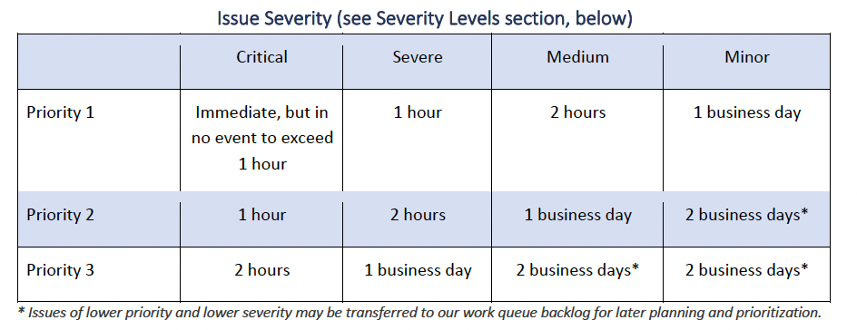
Response times apply on a 24x7 basis, and after normal business hours and on holidays, as necessary to support Versaterm’s obligations under the Service Schedule.
  - Severity levels
The severity levels shown in the table above are defined as follows:
  - Critical: Complete degradation — all users and critical functions affected. Item or service completely unavailable.
  - Severe: Significant degradation — a large number of users or critical functions affected.
  - Medium: Limited degradation — a limited number of users or functions affected. Business processes can continue.
  - Minor: Small degradation — few users or one user affected. Business processes can continue.
The following table are examples of support item types and priority levels:
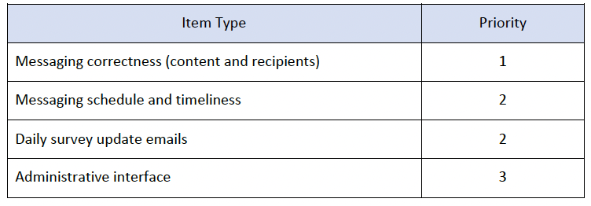
  - Resolution times
Versaterm will always endeavor to resolve problems as swiftly as possible. It recognizes that the Customer’s operational systems and community relationships are key to its mission and that any downtime can have significant consequences. However, Versaterm is unable to provide guaranteed resolution times. This is because the nature and causes of problems can vary enormously.
For instance, it may be possible to resolve a critical API issue in minutes, simply by restarting the affected component(s). But if a system fails due to a persistent infrastructure fault (also classed as a critical issue) it may take longer to get back up and running. In all cases, Versaterm will make its best efforts to resolve problems as quickly as possible. It will also provide frequent progress reports to the Customer.

[remainder of page left intentionally blank]

Versaterm Public Safety US, Inc.

By: _________________________
Name: [name of signer]
Title: [title of signer]
Date: [date]

Customer

By: _________________________
Name: [name of signer]
Title: [title of signer]
Date: [date]

